SQL ASSIGNMENT 4

1. Print the Total price of orders which have the products supplied by 'Exotic Liquids' if the price is > 50 and also print it by Shipping company's Name.

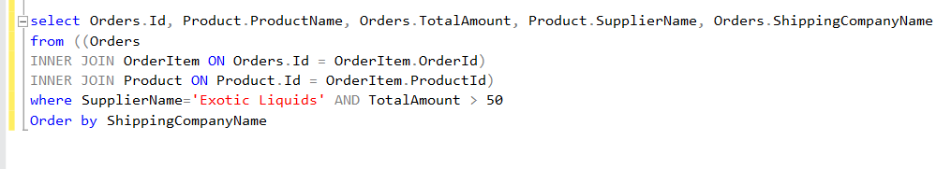

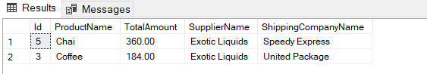

2. Display the employee details whose joined at first.



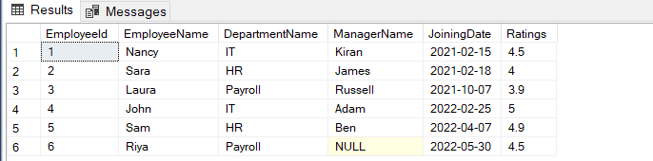

3. Display the employee details whose joined at recently.



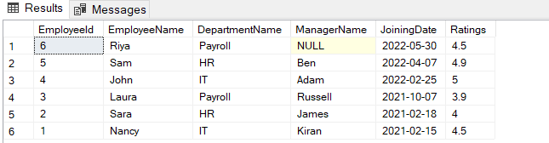

4. Write a query to get most expensive and least expensive Product list (name and unit price).

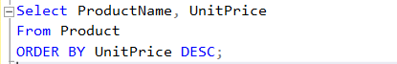

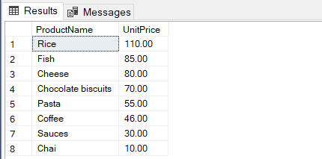

5. Display the list of products that are out of stock.

select \* from Product

where UnitInStock=0

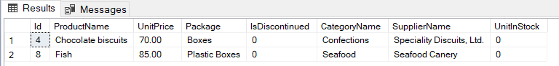

6. Display the list of products whose unit in stock is less than unit on order.

select P.\*

from Product P

INNER JOIN OrderItem OI

ON P.Id=OI.ProductId

where P.UnitInStock<OI.Quantity

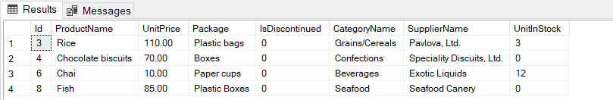

7. Display list of categories and suppliers who supply products within those categories.



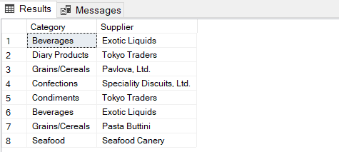

8. Display complete list of customers, the OrderID and date of any orders they have made.

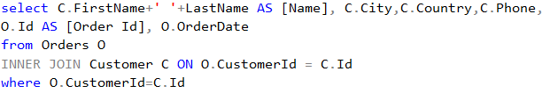

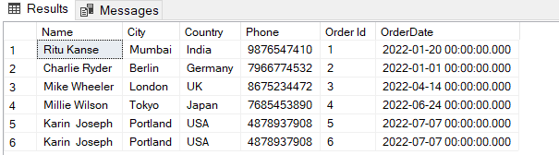

9. Write query that determines the customer who has placed the maximum number of orders.

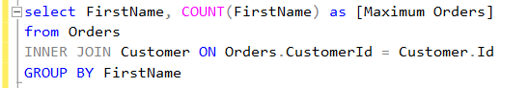

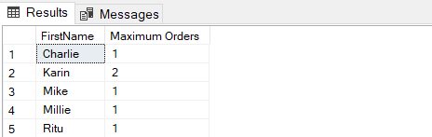

10. Display the CustomerId whose name has substring ‘RA’.



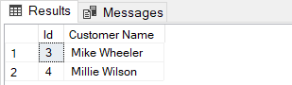

11. Display the first word of all the company name.



